SQL Comments

🌟 Definition
# Source: AI Source: Provided by: [Data Path: Persons Table -> ID Column: 1, Name_En Column: Motasem Essam] -> From: [ChatGPT] on [6/11/2026]
SQL Comments are notes or explanations written inside SQL code that are ignored by the database engine.
Comments are used to:
- Explain SQL code
- Document queries
- Make code easier to understand
- Temporarily disable SQL statements during testing
The database does not execute comments.

🎯 Purpose
# Source: AI Source: Provided by: [Data Path: Persons Table -> ID Column: 1, Name_En Column: Motasem Essam] -> From: [ChatGPT] on [6/11/2026]
SQL comments help developers:
- Understand code faster
- Add explanations
- Document database scripts
- Debug SQL statements
- Collaborate with other developers

🧠 Simple Example
# Source: AI Source: Provided by: [Data Path: Persons Table -> ID Column: 1, Name_En Column: Motasem Essam] -> From: [ChatGPT] on [6/11/2026]
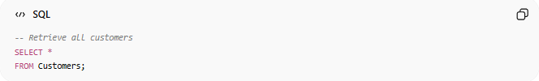
-- Retrieve all customers
SELECT *
FROM Customers;
The comment:
Retrieve all customers
is ignored by the database.
Only the SELECT statement is executed.

📝 Types of SQL Comments
# Source: AI Source: Provided by: [Data Path: Persons Table -> ID Column: 1, Name_En Column: Motasem Essam] -> From: [ChatGPT] on [6/11/2026]
There are two main types:
- Single-Line Comments
- Multi-Line Comments

1️⃣ Single-Line Comments
# Source: AI Source: Provided by: [Data Path: Persons Table -> ID Column: 1, Name_En Column: Motasem Essam] -> From: [ChatGPT] on [6/11/2026]
Used for short comments.
Syntax:

-- Comment text
Example:
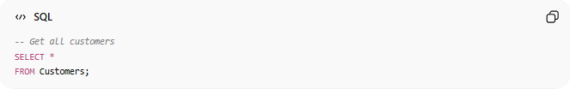
-- Get all customers
SELECT *
FROM Customers;

Another Example
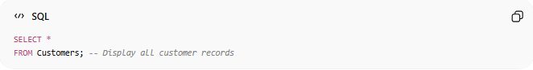
SELECT *
FROM Customers; -- Display all customer records
Everything after -- on that line is treated as a comment.

2️⃣ Multi-Line Comments
# Source: AI Source: Provided by: [Data Path: Persons Table -> ID Column: 1, Name_En Column: Motasem Essam] -> From: [ChatGPT] on [6/11/2026]
Used for longer explanations.
Syntax:
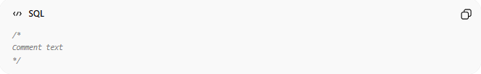
/*
Comment text
*/
Example:
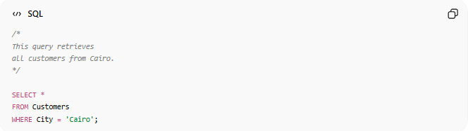
/*
This query retrieves
all customers from Cairo.
*/

SELECT *
FROM Customers
WHERE City = 'Cairo';

📚 Real-World Example
# Source: AI Source: Provided by: [Data Path: Persons Table -> ID Column: 1, Name_En Column: Motasem Essam] -> From: [ChatGPT] on [6/11/2026]
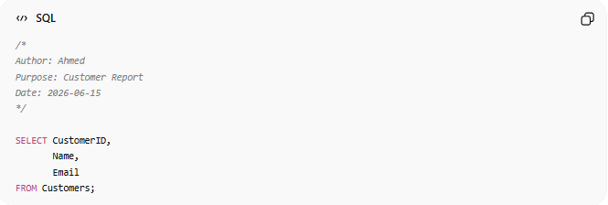
/*
Author: Ahmed
Purpose: Customer Report
Date: 2026-06-15
*/

SELECT CustomerID,
Name,
Email
FROM Customers;
The comment documents the query.

⚖️ Side-by-Side Comparison
# Source: AI Source: Provided by: [Data Path: Persons Table -> ID Column: 1, Name_En Column: Motasem Essam] -> From: [ChatGPT] on [6/11/2026]
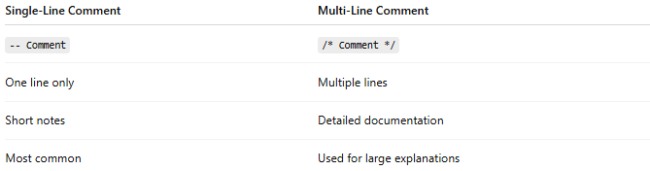
Single-Line Comment | Multi-Line Comment
-- Comment | /* Comment */
One line only | Multiple lines
Short notes | Detailed documentation
Most common | Used for large explanations

🔍 Commenting Out Code
# Source: AI Source: Provided by: [Data Path: Persons Table -> ID Column: 1, Name_En Column: Motasem Essam] -> From: [ChatGPT] on [6/11/2026]
Comments can temporarily disable SQL code.
Example:
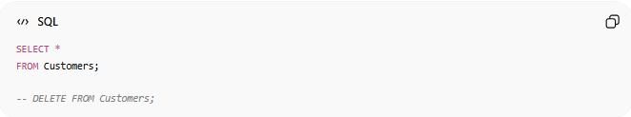
SELECT *
FROM Customers;

-- DELETE FROM Customers;
The DELETE statement will not run.

Multi-Line Disable Example
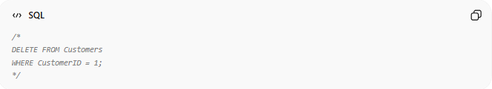
/*
DELETE FROM Customers
WHERE CustomerID = 1;
*/
Everything inside the comment block is ignored.

📊 Common Uses of Comments
# Source: AI Source: Provided by: [Data Path: Persons Table -> ID Column: 1, Name_En Column: Motasem Essam] -> From: [ChatGPT] on [6/11/2026]
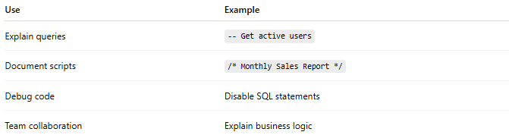
Use | Example
Explain queries | -- Get active users
Document scripts | /* Monthly Sales Report */
Debug code | Disable SQL statements
Team collaboration | Explain business logic

⚠️ Best Practices
# Source: AI Source: Provided by: [Data Path: Persons Table -> ID Column: 1, Name_En Column: Motasem Essam] -> From: [ChatGPT] on [6/11/2026]
✅ Write Meaningful Comments
Good:
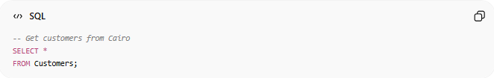
-- Get customers from Cairo
SELECT *
FROM Customers;

Bad:
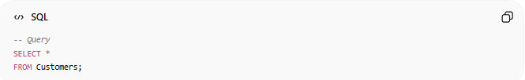
-- Query
SELECT *
FROM Customers;
The comment adds little value.

✅ Use Multi-Line Comments for Documentation
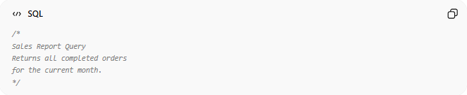
/*
Sales Report Query
Returns all completed orders
for the current month.
*/

✅ Keep Comments Updated
Incorrect comments can be misleading.
Bad:
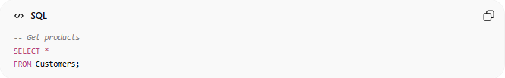
-- Get products
SELECT *
FROM Customers;
Comment and query do not match.

🧠 Simple Analogy
# Source: AI Source: Provided by: [Data Path: Persons Table -> ID Column: 1, Name_En Column: Motasem Essam] -> From: [ChatGPT] on [6/11/2026]
Think of comments as sticky notes in a book.
The notes help readers understand the content:
"This chapter is important."
But the notes are not part of the actual story.
Similarly:
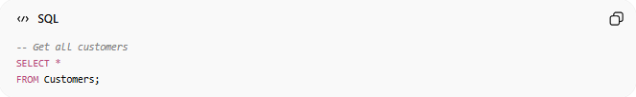
-- Get all customers
SELECT *
FROM Customers;
The comment helps humans understand the query, but the database ignores it.

🧭 Summary
# Source: AI Source: Provided by: [Data Path: Persons Table -> ID Column: 1, Name_En Column: Motasem Essam] -> From: [ChatGPT] on [6/11/2026]
SQL Comments are notes written inside SQL code that are ignored by the database engine. They are used to explain queries, document scripts, improve readability, assist debugging, and support collaboration. SQL supports single-line comments using -- and multi-line comments using /* ... */. Comments make SQL code easier to maintain without affecting execution.

